Name: __________________________________________ Date: _________
Practice Review Questions - ROME Mrs. Valdes

Directions: Select the best possible answer that completes the following statements or questions and fill in the appropriate choice on the scantron provided.

1) One reason that the Roman Empire succeeded was that it:
- was near the Tigris and Euphrates Rivers
- had no contact with the rest of the world
- followed Islamic beliefs
- developed extensive trade.

2) Which term correctly identifies common Romans at the bottom of the social pyramid - typically farmers, craftsman and merchants?
1. Plebeians 3. Patricians
2. Tribunes 4. Vandals

3) A major impact of Ancient Greece and Rome on the modern world was that:

1. the Greeks and Romans succeeded in achieving a classless society, which was later copied in Western Europe
2. Greek sculpture and Roman architecture were much admired and copied in the 18th and 19th centuries
3. Greece and Rome transmitted Islamic philosophy to the areas they conquered
4. Greek and Latin are still widely spoken in universities throughout the West

4) During the early republic, why was it important that Roman laws were written on 12 tablets and shown to the public?
1. Plebeians could then appeal a judgment made by a patrician judge.
2. Judges could demand that the laws were known so they should be obeyed.
3. Patricians could then work to veto, or block the laws.
4. Judges could not show favoritism to non- Romans.

5) To protect themselves against unjust treatment by patrician officials, the plebeians elected their own officials, called…
1. consuls.
2. tribunes.
3. magistrates.
4. senators.

Base your answers to the following questions on the diagram below and your knowledge of social studies.

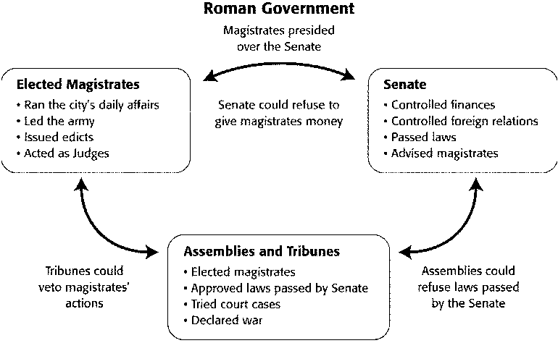
6) The chart titled “Roman Government” shows that the Romans designed their government to:
1. promote trade and commerce.
2. centralize power in one person.
3. respond quickly to military attacks.
4. incorporate checks on the power of different parts of government

7) According to the chart titled “Roman Government.” In what way could tribunes check the power of the elected magistrates?
1. by vetoing laws
2. by vetoing the actions of the magistrates
3. by controlling the magistrates’ budget
4 .by passing laws
______________________________________________________________________________

8) By 494 BCE, plebeians got more of a voice in the government of Rome by
1. calling a special election and voting the senate out of office.
2. raising their own army and declaring a civil war.
3. assassinating key senators.
4. refusing to serve in the army.

9) Electing tribunes and displaying the Law of the Twelve Tables:
1. benefited tribunes.
2. showed the influence of the Etruscans.
3. protected plebeians against unjust treatment by patricians.
4. violated the constitution hammered out by patricians and plebeians.

10) A republican government is one in which…
1. all citizens have the right to vote.
2. decision making power has been given to representatives.
3. citizens do not have equal rights under the law.
4. there is more than one political party.

11) One reason why most conquered people remained loyal to Rome was that Rome…
1. Gave them their independence
2. gave them equal partnership the senate.
3. did not require them to pay taxes.
4. gave them the opportunity to gain Roman Citizenship

12) The political system of the ancient Roman Empire was characterized by
1. a strong central government
2. rule by a coalition of emperors and religious leaders
3. universal suffrage in national elections
4. a strict adherence to constitutional principles

13) Julius Caesar was considered a great leader in ancient Rome because he:
1. Taxed everyone equally
2. Put changes in place that helped the commoners
3. Made changes to help the wealthy patricians
4. Married a widow and adopted her two sons

14) Why did a group of senator murder Julius Caesar?
1. because he was extremely unpopular with the Roman people
2. to dismantle the Republic and return governing power to the monarchy
3. because he was waging a civil war
4. to prevent him from taking away their power.

14) The Pax Romana refers to a period of Roman history in which there was…
1. relative peace and stability throughout the empire.
2. constant warfare with the barbarian tribes.
3. a transition from the Republic to Empire.
4. Julius Caesar ruled the Roman Republic.

15) Augustus helped to ensure good government during and after his rule by
1. rebuilding the city of Rome.
2. creating different monetary systems throughout the empire.
3. opening the civil services to talented individuals.
4. ruling as a ruthless dictator.

16) A major contribution of the Roman Republic to Western society was the development of…
1. gunpowder.
2. the concept of direct democracy.
3. monotheism.
4. the concept of all people being equal in the eyes of the law.

17) What contributed to the economy declining of the late Roman empire?
1. A decline in population led to a shortage of soldiers.
2. Low taxes helped to push people from poverty into the middle class.
3. Asian trade routes were blocked by the eastern Roman empire.
4. Nobles would not pay taxes, so Rome could not support its armies.

18) How did Romans supply their cities with water?
1. Romans built their cities where there were natural springs
2. Roman engineers built aqueducts that carried water to their cities
3. Romans only built cities near rivers
4. Romans relied exclusively on rainfall to supply water for their cities.

19) The Roman Republic was an important influence on later governments. This can best be seen in which of the following institutions?
1. A country ruled by a king.
2. A communist nation ruled by a dictator.
3. A democratic country with checks and balances.
4. A direct democracy in which the people vote on everything.

20) The fall of the Roman Empire can be attributed to which of the following reasons:
1. support in the belief in reincarnation.
2. high taxation and Germanic invasions.
3. the rise of Islam.
4. the amount of Romans volunteering for the army went up.

21) An immediate result of the fall of the Roman Empire was…
1. a period of disorder and weak central government.
2. an increase in trade and manufacturing.
3. a renewed interest in education and the arts.
4. the growth of cities and dominance by the middle class.

The Roman Empire, at its height, expanded across the continents of: (Use the map below)
1. Europe, South America, and Asia
2. North America, South America, and Africa
3. Africa, Europe, and Asia
4. India, Asia, and Europe

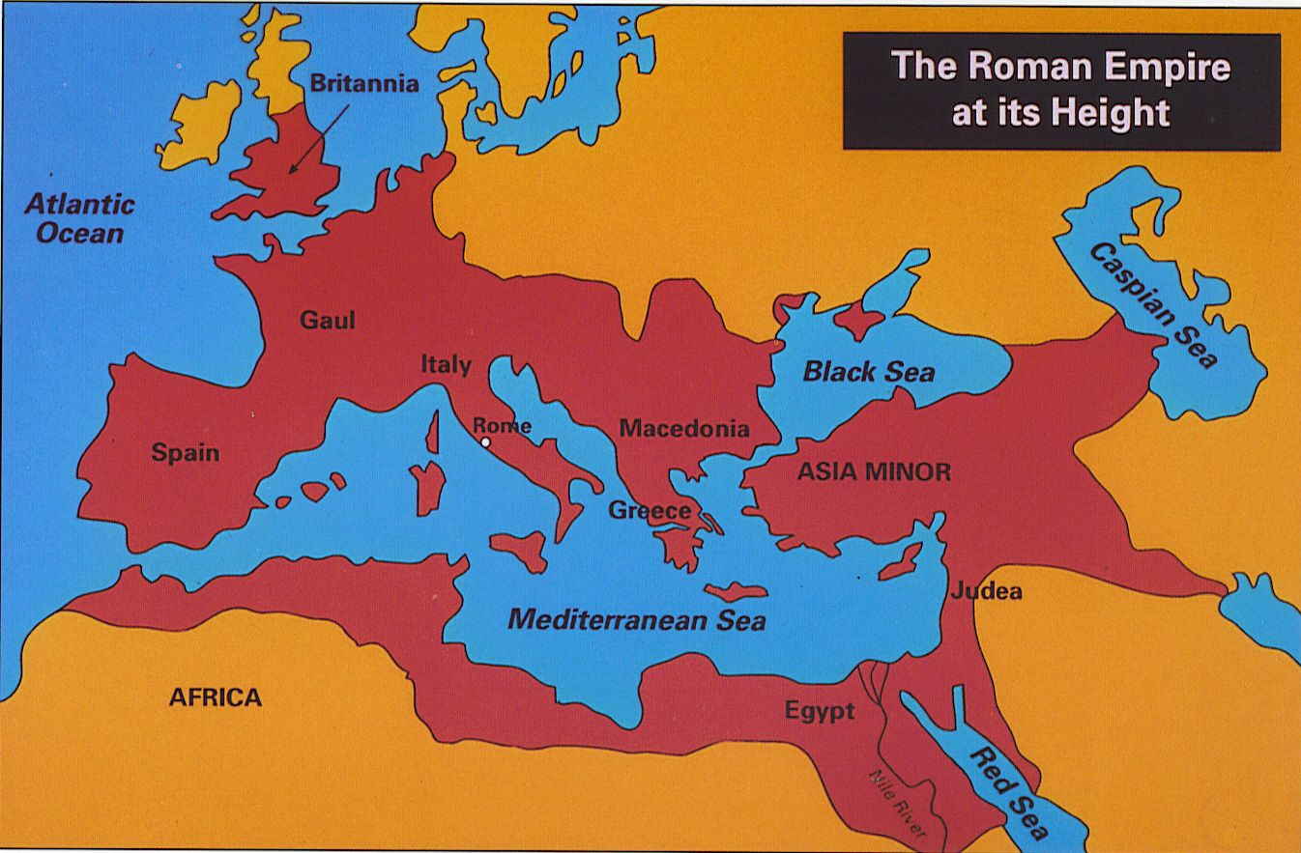

25) After the fall of Rome, the eastern portion of the Roman Empire became known as the…
1. Persian Empire.
2. Mongol Empire.
3. Byzantine Empire.
4. Gupta Empire.

Part II: Constructed Response (25 points)
Directions: Read the documents and answer the questions that follow. As you analyze the documents take into account both the source of each document and the author’s point of view. Write your answers in your own words on the lines below.

Document 1

- Who were the Roman roads created by? Why? (2 points)
_______________________________________________________________________________________________________________________________________________________________________________________________________________________________________________________________________________________________________________________________________________________________________________________________________________________________________________________________________________________________________________________________
- Describe the effects the Roman Roads had on the Roman Empire. (3 points)

_______________________________________________________________________________________________________________________________________________________________________________________________________________________________________________________________________________________________________________________________________________________________________________________________________________________________________________________________________________________________________________________________
Document 2

3. What was the purpose of the aqueducts and why were they so important to Roman society? (3 points)
__________________________________________________________________________________________________________________________________________________________________________________________________________________________________________________________________________________________________________________________________________________________________________________________________________________________________________________________________________________________________________________________________________________________________
Document 3
- What were the purposes of the Coliseum and the Circus Maximus? (3 points)
_____________________________________________________________________________________________________________________________________________________________________________________________________________________________________________________________________________________________________________________________________________________________________________
- What architectural and building techniques and technology are present? How else did the Romans use these techniques and/or technology? (3 points)
________________________________________________________________________________________________________________________________________________________________________________________________________________________________________________________________________________________________________________________________________________________________________________________________________________________________________________________________________________________________________________________________________________________________________________________________________

Document 4
- Identify two rights guaranteed to citizens by these laws. Explain how the Roman Legal Code create stability during the Roman Empire? (3 points)

__________________________________________________________________________________________________________________________________________________________________________________________________________________________________________________________________________________________________________________________________________________________________________________________________________________________________________________________________________________________________________________________________________________________________________________________________________________________________________________________________________________________________________________________________________________________________________________________________________________________________
Document 5
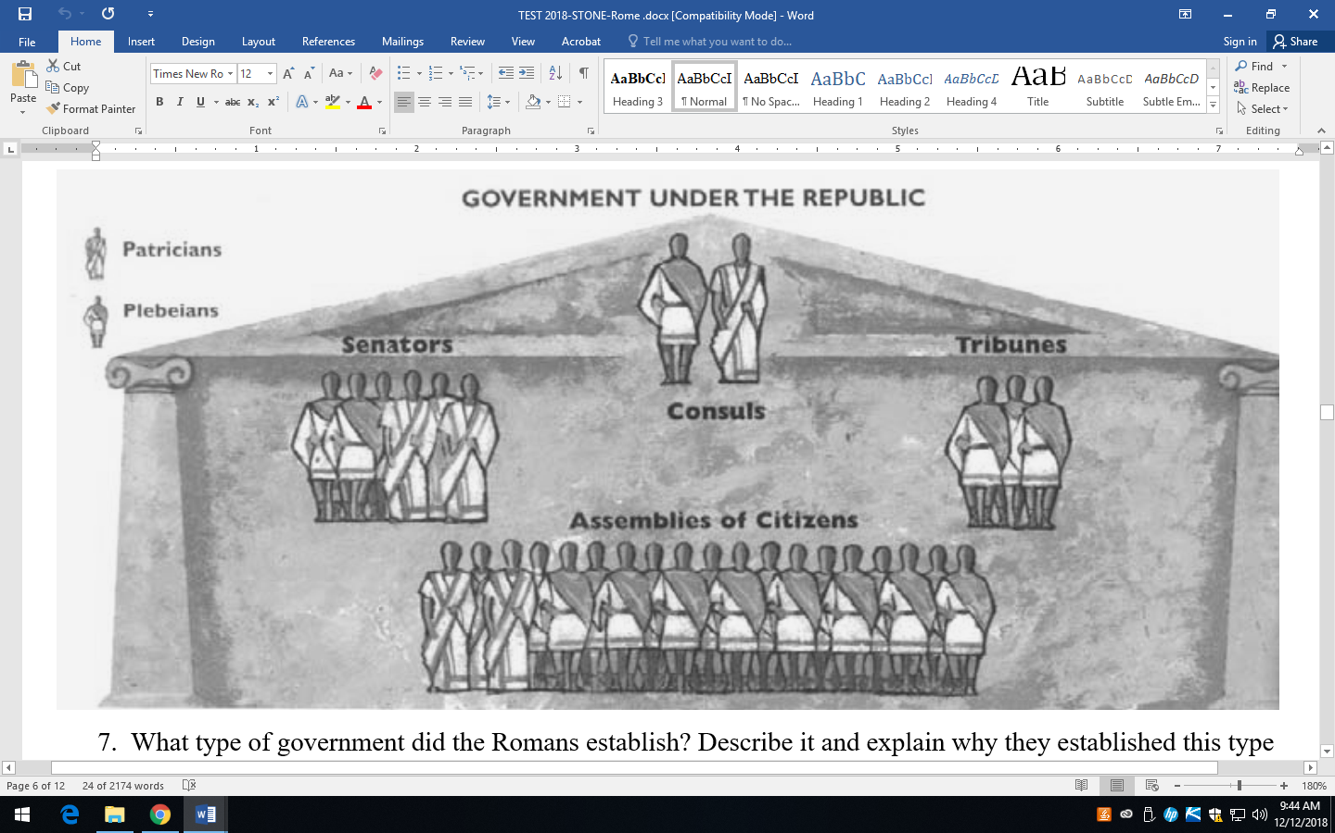
- What type of government did the Romans establish? Describe it and explain why they established this type of government. (2 points)
_______________________________________________________________________________________________________________________________________________________________________________________________________________________________________________________________________________________________________________________________________________________________________________________________________________________________________________________________________________________________________________________________

- What governmental concept shown in the diagram is considered an achievement of Roman society? How does this concept impact the world today? (3 points)

________________________________________________________________________________________________________________________________________________________________________________________________________________________________________________________________________________________________________________________________________________________________________________________________________________________________________________________________________________________________________________________________________________________________________________________________________________________________________________
Document 6
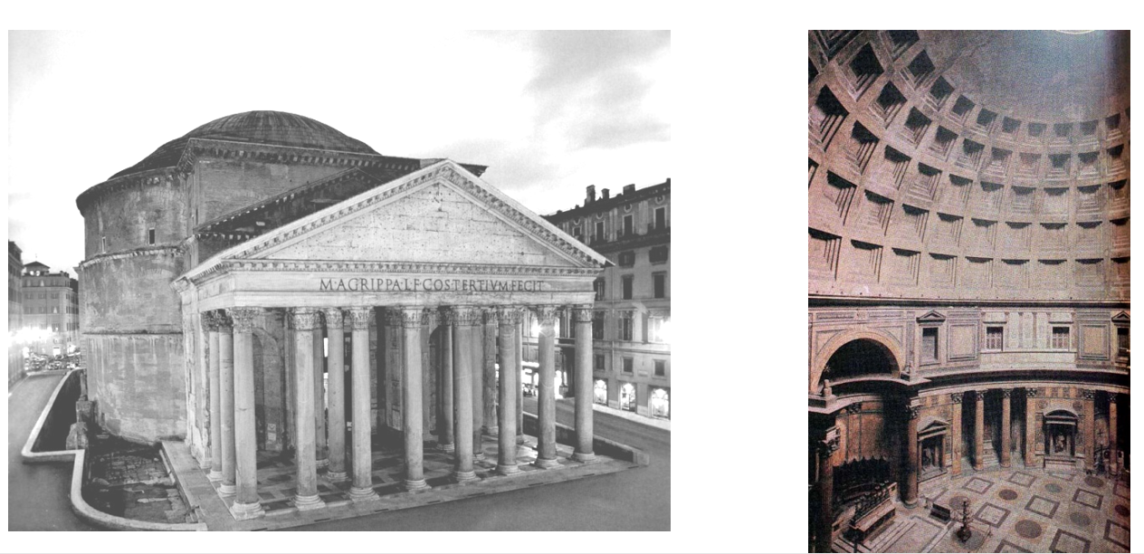
- What building is shown in the pictures above? (1 point)

__________________________________________________________________________________________________________________________________________________
- What architectural feature is present? Why is this feature so important to future architectural structures? (2 points)

____________________________________________________________________________________________________________________________________________________________________________________________________________________________________________________________________________________________________

